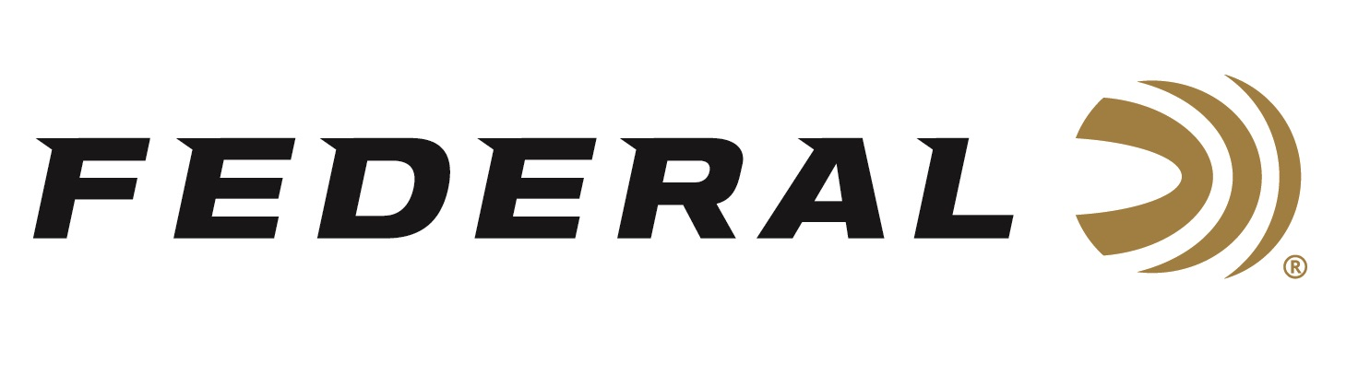

FOR IMMEDIATE RELEASE

Elk Ecstasy on “It’s Federal Season” Podcast

ANOKA, Minnesota – November 10, 2022 – On this episode of the “It’s Federal Season” podcast, guest host Janis Putelis of MeatEater talks elk hunting with good friend Jason Phelps. The pair share their experienced insights on everything the do-it-yourself elk hunter needs to know before making those initial plans to hunt in elk country including listing the top states to elk hunt.

Episode #41 “Elk Ecstasy”
https://www.federalpremium.com/this-is-federal/podcast/

“Very few hunters have as much experience and expertise to share like Jason Phelps,” said Janis Putelis of MeatEater. “His words are backed by countless hours of hunting and guiding, and it was a pleasure to hear from him on factors such as elevation, understanding the weather conditions, and his choices on gear including cartridge recommendations.”

In the Tech Talk segment, Mike Holm, Rifle Global Product Director weighs in on the best bullet construction for elk to effectively bring down one of North America’s largest game animals. Included in the conversation is a detailed review of Terminal Ascent from Federal Ammunition. This is a conversation between three experts for enthusiasts that is elk ecstasy.

For this episode, besides listening on the Federal Premium website or Talk North podcast network, you can also subscribe to Federal Ammunition’s YouTube channel (https://www.youtube.com/user/federalpremiumammo) and tune in for the discussion.

Federal Ammunition can be found at dealers nationwide. For more information on all products from Federal or to shop online, visit www.federalpremium.com.

Press Release Contact: JJ Reich
Senior Manager – Press Relations
E-mail: VistaPressroom@VistaOutdoor.com

About Federal Ammunition
Federal, headquartered in Anoka, MN, is a brand of Vista Outdoor Inc., an outdoor sports and recreation company. From humble beginnings nestled among the lakes and woods of Minnesota, Federal Ammunition has evolved into one of the world's largest producers of sporting ammunition. Beginning in 1922, founding president, Charles L. Horn, paved the way for our success. Today, Federal carries on Horn's vision for quality products and service with the next generation of outdoorsmen and women. We maintain our position as experts in the science of ammunition production. Every day we manufacture products to enhance our customers' shooting experience while partnering with the conservation organizations that protect and support our outdoor heritage. We offer thousands of options in our Federal Premium and Federal® lines-it's what makes us the most complete ammunition company in the business and provides our customers with a choice no matter their pursuit.

